const int SIZE = 85;

Lec11

FILE *fptr;

Fptr = fopen(filename, mode);

Filename is a string

Mode = “r” or “w” or “a” for appending

If read, check if(fptr==NULL)

fclose(fptr);

fscan(fptr, “%d”, &intNum);

while loop with top as param != EOF

fprintf(fptr, "%s is %d\n", name, data);

char s1[20]; //one string

char s2[5][20]; //array of five strings

getchar ( );

putchar();

char name[8]="Welcome";

int x[3][4] = {{0,1,2,3}, {4,5,6,7}, {8,9,10,11}};

#define PI 3.14159

Strings and character library

■ #include <string.h>

■ #include <ctype.h>

<string.h> -- string manipulation functions

■ strlen() – length of a string

■ strcpy() – string copy

■ strcmp() – string comparison

■ strcat() – string concatenation

■ more in Chapter 8 (C How to Program)

■ <ctype.h> -- character manipulation macros or functions

■ many character test macros

■ case conversion functions

Character test Macro name True (nonzero) if ‘c’ is in range

Alphanumeric isalnum(c) a-z, A-Z, 0-9

Alphabetic isalpha(c) a-z, A-Z

Numeric digit isdigit(c) 0-9

Lower case islower(c) Lower case characters

Upper case isupper(c) Upper case characters

White space isspace(c) Space, tab and so on

■ char *strcpy (char *s1, const char *s2);

■ Copies string s2 into array s1 including '\0'

■ char *strncpy (char *s1, const char *s2, size_t n);

■ Copies at most n characters of string s2 into array s1

■ You need to add '\0' manually to s1

**rm –r directory** :remove a directory

(This will delete all the files and directories

under that directory. No way to recover!)

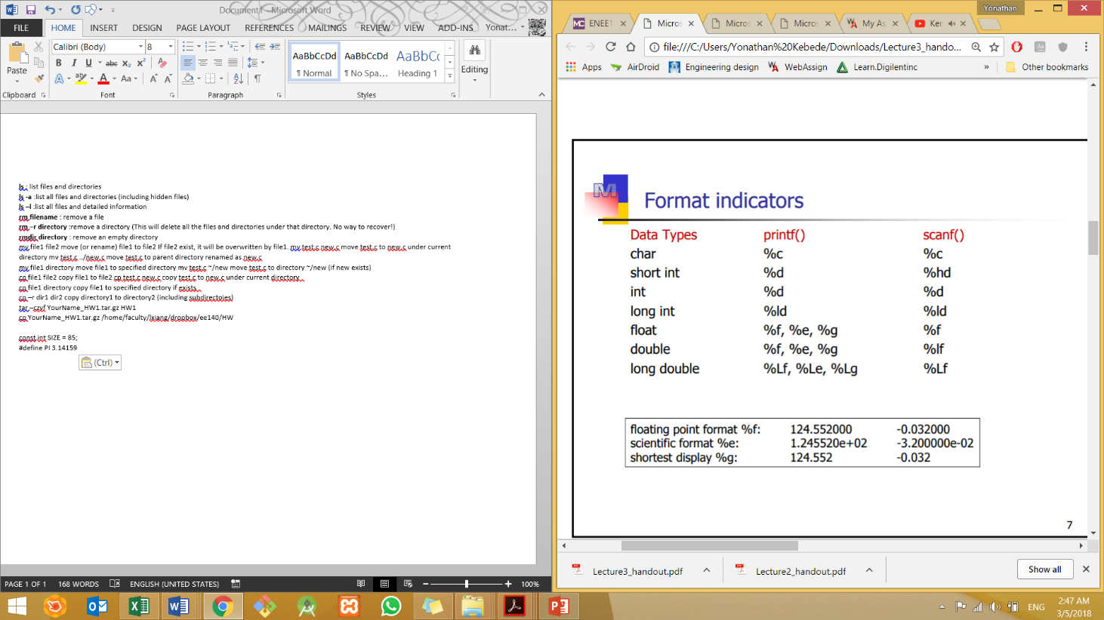**rmdir directory** : remove an empty directory

Lec10

